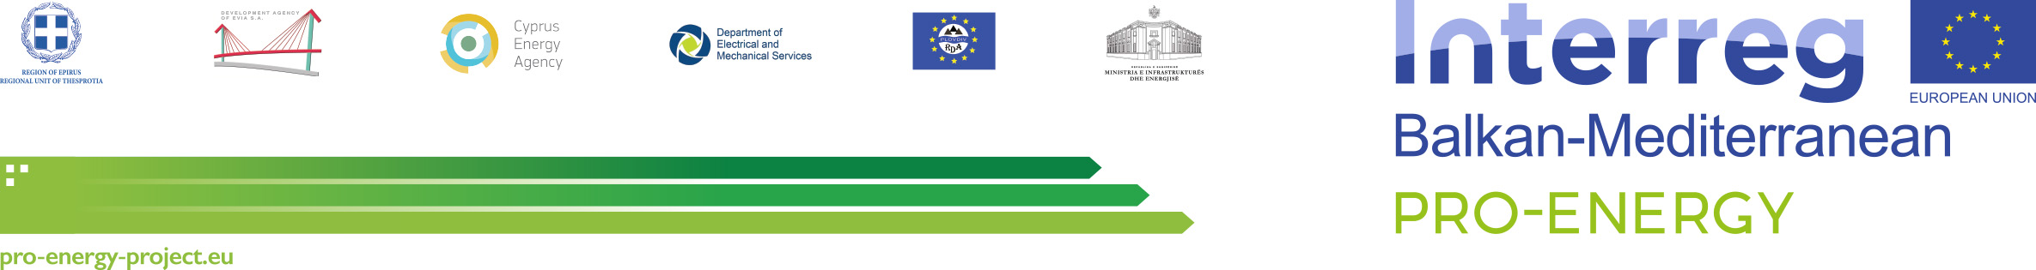

PROJECT

PRO-ENERGY – PROMOTING ENERGY EFFICIENCY IN PUBLIC BUILDINGS OF THE BALKAN MEDITERRANEAN TERRITORY

Work Package: | [Number and name of Working Package]
Activity: | [Number and name of Activity]
Activity Leader: | [Name of Partner]
Deliverable: | [Number and name of Deliverable]

Version: | Draft 1.0 | Date: | ../../..
Type: | [Type of deliverable]
Availability: | Confidential
Responsible Partner: | [Name of Partner]
Editor: | [Name of Editor]

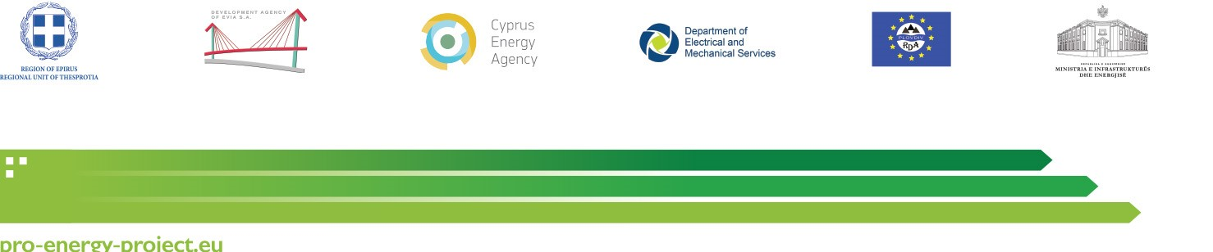

DISCLAIMER:

This publication has been produced with the financial assistance of the European Union under the Interreg Balkan‐Mediterranean 2014‐2020. The contents of this document are the sole responsibility of the [Name of the Partner], and can under no circumstances be regarded as reflecting the position of the European Union or of the Programme’s management structures.
CONTENTS

IDENTIFICATION SHEET 5
INTRODUCTION 6
1. ………………………………………………. 7
1.1. …………………………………………………………….. 7
1.1.1. …………………………………………………………….. 7

IDENTIFICATION SHEET

Project Ref. No. | BMP1/2.2/2052/2019
Project Acronym | PRO-ENERGY
Project Full Title | ‘Promoting Energy Efficiency in Public Buildings of the Balkan Mediterranean territory’

Security (distribution level) | Confidential
Date of delivery | ../../..
Deliverable number | [Number of the current deliverable]
Type | [Type of deliverable]
Status & version | Draft 1.0
Number of pages | [Pages number]
ACTIVITY contributing to the deliverable | [Number and name of Activity]
Responsible partner | [Name of Partner]
Editor | [Name of Editor]

INTRODUCTION

PRO-ENERGY is a transnational cooperation project, co-financed by the Cooperation Programme “Interreg V-B Balkan Mediterranean 2014-2020”, under Priority Axis 2, Specific Objective 2.2 Sustainable Territories. The project aims at promoting Energy Efficiency in public buildings in the Balkan Mediterranean territory and to create a practical framework of modelling and implementing energy investments interventions, through specific ICT monitoring and control systems, as well as through energy performance contracting (EPC). The specific objective of PRO-ENERGY is to reduce by more than 20% the energy spending in public buildings of the participating entities in one year after the implementation of pilot actions.

Based on the above, Work Package … (WP …) “………………………………………………………………….” aims at ……………………………………………………………………………………………………………………………………

More specifically, Activity X.X “………………………………………………………………….” aims to:
- ……………………………………………………………………………………………………………………………………
- ……………………………………………………………………………………………………………………………………

SECTION 1

……………………………………………….

……………………………………………………………..

……………………………………………………………..

